|  |
| --- |
|  |
| Agendamiento de Citas |
| Prototipo de Bajo nivel |
|  |
| **[JUAN CARLOS SALINAS]** |
| **11/13/2018** |

[Type the abstract of the document here. The abstract is typically a short summary of the contents of the document. Type the abstract of the document here. The abstract is typically a short summary of the contents of the document.]

Table of Contents

[To update the table of contents, right click the message below and select Update Field (F9 on PC, ⌥⌘U on Mac).]

**No table of contents entries found.**

1. Pages
   1. Page Tree

Home  
 Page 2  
 Page 3

* 1. Home
     1. User Interface

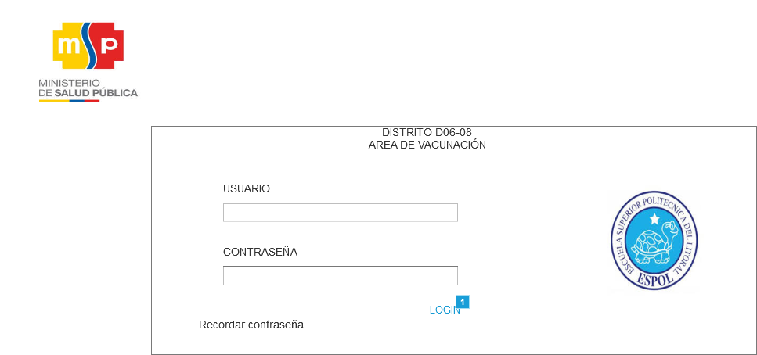

* + 1. Widget Table

|  |  |
| --- | --- |
| Footnote | Interactions |
| 1 | OnClick:  Case 1:  Open Page 2 in Current Window |

* 1. Page 2
     1. User Interface

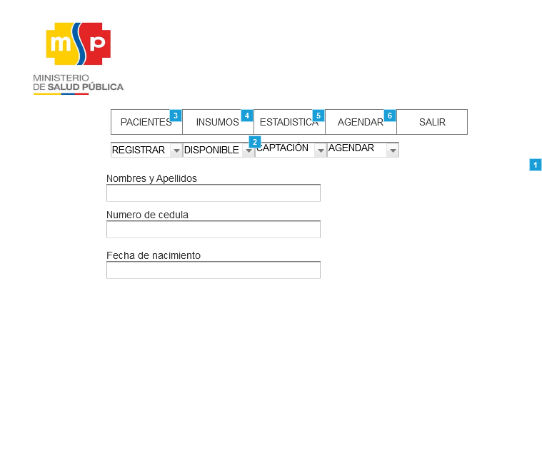

* + 1. Widget Table

|  |  |
| --- | --- |
| Footnote | Interactions |
| 1 | OnClick:  Case 1:  Set Selected  Set Selected |
| 2 | OnClick:  Case 1:  Show (Dynamic Panel) |
| 3 | OnClick:  Case 1:  Set (Dynamic Panel) to State1 |
| 4 | OnClick:  Case 1:  Set (Dynamic Panel) to State2 |
| 5 | OnClick:  Case 1:  Set (Dynamic Panel) to Next |
| 6 | OnClick:  Case 1:  Set (Dynamic Panel) to State4 |

* + 1. Unnamed
       1. State1
       2. User Interface

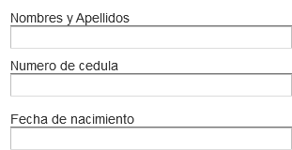

* + - 1. State2
      2. User Interface

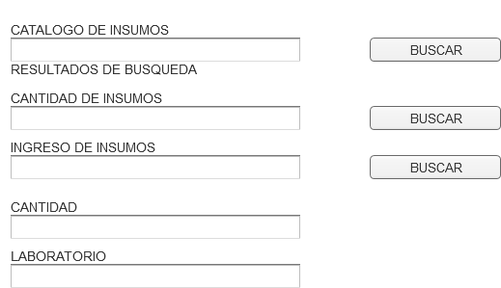

* + - 1. State3
      2. User Interface

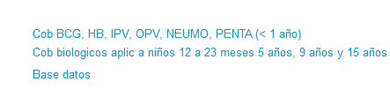

* + - 1. State4
      2. User Interface

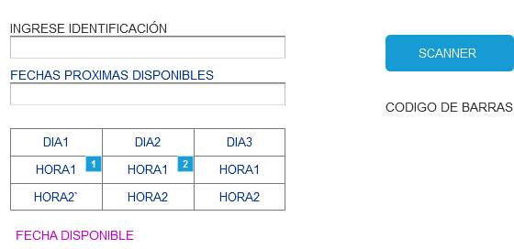

* + - 1. Widget Table

|  |  |
| --- | --- |
| Footnote | Interactions |
| 1 | OnClick:  Case 1:  Set (Dynamic Panel) to State1 |
| 2 | OnClick:  Case 1:  Set (Dynamic Panel) to State2 |

* + 1. Unnamed
       1. State1
       2. User Interface



* + - 1. State2
      2. User Interface



* 1. Page 3